Check Valve Instruction Manual
1. Scope
This instruction manual covers swing check valves and lift check valves with nominal diameters DN15 mm to 600 mm (1/2" to 24"), nominal pressures PN1.6 MPa to 16 MPa (ANSI CLASS 150 to 900), available in threaded ends, flanged ends, butt-weld ends, and socket-weld ends.
2. Applications
2.1 This valve is used in pipelines or equipment to prevent the backflow of medium.
2.2 Valve materials shall be selected based on the medium.
2.2.1 Carbon steel valves are suitable for water, steam, oil, and similar media.
2.2.2 Stainless steel valves are suitable for corrosive media.
2.3 Applicable temperature range:
2.3.1 Standard carbon steel valves: -29°C to +425°C
2.3.2 Alloy steel valves: ≤ 550°C
2.3.3 Stainless steel valves: -196°C to +200°C
3. Structure
3.1 The basic structure of the check valve is shown in Figure 1.
3.2 Wear-resistant gaskets are made of PTFE or flexible graphite, providing reliable sealing.
4. Operating Principle
The check valve opens and closes automatically based on the direction of medium flow, preventing backflow.
5. Storage, Maintenance, Installation, and Use
5.1 Valves shall be stored indoors in a dry and ventilated area, with both pipe openings sealed.
5.2 Valves stored for extended periods shall be inspected regularly; debris shall be removed. Pay special attention to keeping the sealing faces clean to prevent damage.
5.3 Before installation, verify that the valve markings match the requirements.
5.4 Before installation, inspect the valve interior and sealing faces; if any contaminants are present, wipe clean with a soft cloth.
5.5 Before installation, ensure that the flow-direction arrow on the valve aligns with the medium flow direction.
5.6 Lift-type vertical-disc check valves shall be installed on vertical pipelines; lift-type horizontal-disc check valves and swing check valves shall be installed on horizontal pipelines.
5.7 During operation, monitor for any abnormal sounds or vibrations. To prevent water hammer in the pipeline, pay attention to fluctuations in medium pressure.
6. Possible Faults, Causes, and Resolutions — See Table 1
Possible Fault | Cause | Resolution
Valve fails to close | Debris trapped between disc and seat | Remove and clean; flush the pipeline
Disc does not open | Disc is obstructed or spring is damaged (if spring-assisted) | Inspect, repair or replace the disc/spring
Leakage at the seal | Sealing face is damaged or gasket is worn | Re-grind or replace the seat; replace the gasket
Abnormal vibration/noise | Excessive flow velocity or water hammer | Install a slow-closing check valve or surge suppressors; reduce system pressure
7. Warranty
The manufacturer warrants the valve for one year from the date of initial operation, but no later than 18 months from the date of shipment. Under warranty, any faults caused by product quality issues will be repaired or have parts replaced free of charge.

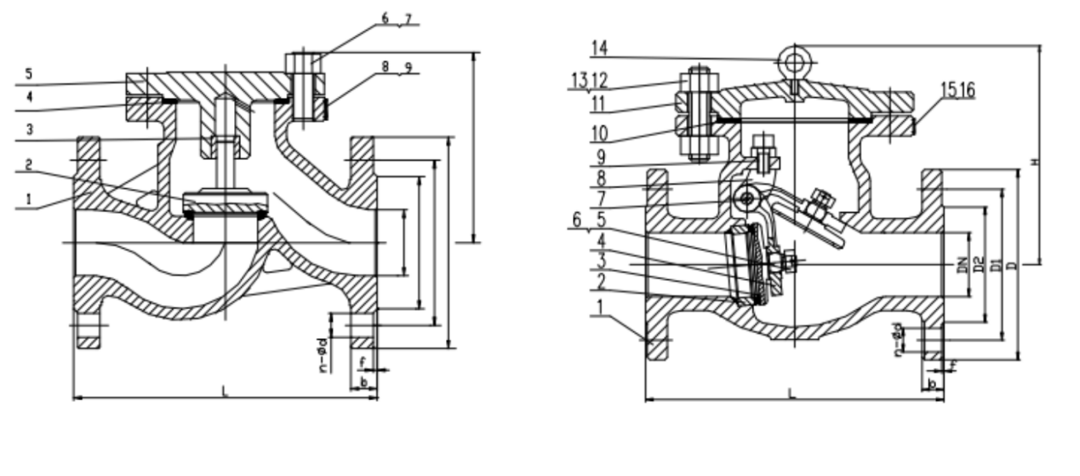
a.Flanged Lift Check Valve b.Flanged Swing Check Valve


WEIZIDOM GROUP
www.wsdvalves.com
South City, Longhu Town, Xinzheng City,
Zhengzhou City, Henan Province, China

